
Name: Conor Cunniffe
Student ID Number: G00346183@gmit.ie
Module: Software Testing
Title: Test plan for Game Development International Ltd
Date: 10/5/2020
Github: https://github.com/G00346183/SoftwareTestingyear4

Contents
Introduction 2
OBJECTIVES AND TASKS 3
Objectives 3
Tasks 3
SCOPE 3
General 3
Tactics 4
Testing Strategy 6
Alpha Testing (Unit Testing) 6
System and Integration Testing 7
Performance and Stress Testing 7
User Acceptance Testing 8
Batch Testing 8
Automated Regression Testing 8
Beta Testing 8
Hardware Requirements 8
Environment Requirements 9
Main Frame 9
Workstation 9
Test Schedule 9
Control Procedures 9
Features to Be Tested 9
Features Not to Be Tested 9
References: 9

Introduction
- This game will be a 2D side-scrolling platformer, inspired by the likes of ‘Salt and Sanctuary’, ‘Shovel Knight’, and ‘Fancy Pants’, with elements from ‘Skyrim’ (mainly in the way the player character and enemy characters attack). The artwork will be inspired mainly by Shovel Knight, which uses mainly pixel art to create its characters and world. The gameplay will be inspired by ‘Salt and Sanctuary’ and ‘Dark Souls’ and ‘Skyrim’, which will see the player navigate progressively difficult levels with a wizard type character that uses magic a lá ‘Skyrim’. Each level will have several enemies that the player must defeat to progress. Each level will also have a boss that the player must defeat to progress to the next level. Each level will contain pickups for the player, such as health pickups to replenish the player’s health. The purpose of the document is to help test the main aspects of the game, these include the main character health bar, the enemies health bar, the main menu and also the pause menu as the game is being built for android and also PC. The software test will ensure that our software is free from input errors and all the game logic will function as intended. For example:
  - after the game all enemies are defeated a new wave appears on screen stating what level you are now on.
  - enemies and other entities on screen should not behave erratically and all positioning and attack scenarios should be accounted for
  - the player should only be able to use the keys on screen for android and the extra keys on the keyboard for PC serve no purpose in the game.
  - The save and load features of the game are working correctly allowing the user to start off exactly where they left off with the same amount of life and enemies where they saved the game.

OBJECTIVES AND TASKS

Objectives
The objective of our test plan is to find and report as many defects and bugs as possible to improve the security and quality of our software. We will use a many different types tests to achieve these goals. The test plan document supports the following objectives:
- Identify the parts the software that should be tested.
- List the recommended test requirements (high level).
- Recommend and describe the testing strategies to be employed.
- Identify the required resources and provide an estimate of the test efforts.
- List the deliverable elements of the test activities.

Tasks
- Identify what particular tests will be used to test each individual module.
- Identify the expected results for each test on each model.
- Perform these tests.
- Document every little detail. The test data, test cases and also the test configuration used during the testing process.
- Successful unit testing is required before it is eligible for system and integration testing.
- Unsuccessful testing will require a Bug Report to be generated.
- Test documents and reports should be submitted when all the tests are complete.

SCOPE

General
Main Components of the game to be tested:
- Main Menu
- Player Movement
- Enemy Movement
- Enemy damage
- Player health counter
- Enemy health counter
- In-Game pause Menu

Scenario | Strategy to test scenario
Main Menu | Functionality Testing
Player Movement | Functionality Testing, integration testing
Enemy Movement | Functionality Testing, integration testing
Enemy Damage | Functionality Testing, integration testing, Integration testing
Player health Counter | Functionality Testing, integration testing, Integration testing
Enemy health Counter | Functionality Testing, integration testing, Integration testing
In-Game pause Menu | Functionality Testing, integration testing, Integration testing, regression testing, automation testing

Tactics
- Main Menu:
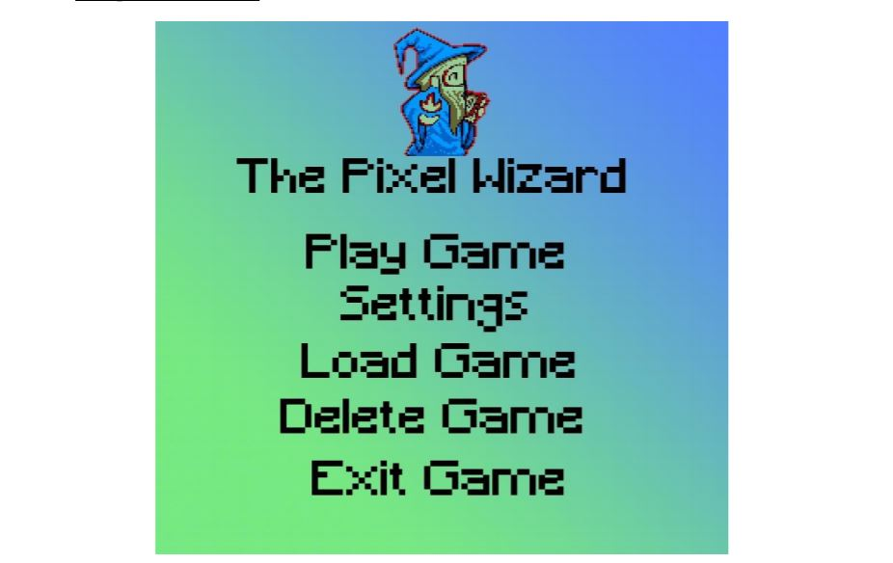
There will be a total of five different buttons on this menu, each one will be tested separately and make sure they have a corresponding feature. Play game starts you off brand new at the very first level.

Setting brings you too a settings Menu, this is where you can adjust the screen size of the windows, increase or decrease The volume of the game and also adjust the level of difficulty.

When pressing the load game a menu pops up with previous saved games, or empty if there is no saved game asserted to that slot, if it is the players first time playing the game all the load slots will be empty.
A maximum of three load game files will be in this menu.

Delete game also brings up the same menu as load game but this time if you select a game instead of bringing you too that saved location its deletes that memory changing it from a saved level to a new file. There will also be a prompt ‘are you sure you wish to delete this saved game’?

Exit game, This shuts down the game window and brings you back to the home screen of the device you are using the play the green. Sometimes this can be clicked by accident so in this game a prompt appears asking the user ‘are you sure you wish to exit this game?’

- Player Movement:
In this part the player first selects any game either from the saved game or new game from the menu and moves the player around the map with the corresponding controls. If the player moves ok and has no problems moving to the designated parts of the map and the controls are correct, this part of the testing is complete.
- Enemy Movement
The movement of the enemies should start off slow and gradually get faster as the level progresses. This is important to keep the user interested and to make the game have a nice difficulty increased bell curve the higher the level the most difficult it will be. This feature will be tested by the client
- Enemy damage
A tester for this part should just play through the levels and make sure every enemy is able to be damaged and none of the enemys are invincible and should keep and eye out and make sure every enemy’s health goes down when it with an attack of the main character.
- Player health counter
Make sure the players health counter goes down as intended and also the player dies when the health counter reaches 0, also make sure the health-up feature pickup works as intended a restores a portion of health
- Enemy health counter
This should go down with every successful attack which hits the enemie, for the purpose of the game enemies cannot attack other enemies but they do absorb the projectiles fired by other and can only be damaged by the main character.
- In-Game pause Menu
This menu should have multiple features that need to be tested and can be seen in the screenshot below.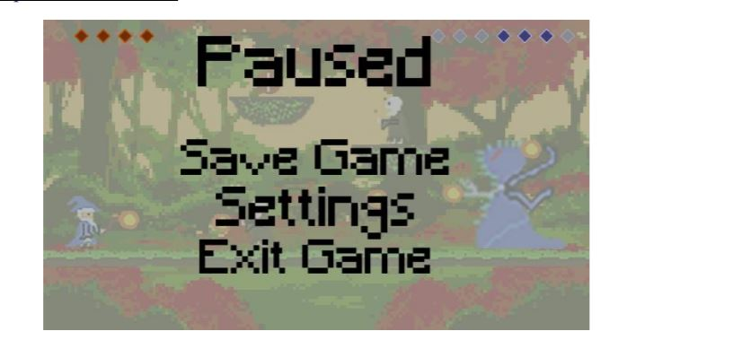

Testing Strategy

Alpha Testing (Unit Testing)
This is Where the game is broken onto multiple smaller parts to be tested individually.
For my game I will be testing the main features of each part with a table diagram, exactly what it was meant to do a weather it passed or failed and how critical it would be for the end game if the feature had bugs.
Feature: | Expected: | Result: | Fail/Pass
Character can move left | Left moves character left | Character moves left. | PASS
Character can fire objectives in a forward motion | Spacebar fires a projectile in direction character is facing. | Character is able to fire projectile in the right direction | PASS
Enemy moves left and right by itself | Enemy moves left and right across the flatform it spawns on. | Enemy moves left and right on platform its placed on. | PASS

Participants: Developers
Methodology: each feature of the game will be written down like in the table above, wit the feature being tested, the expected results, the actual result and weather it needs to be looked at depending if the expected result and actual result are the same. Each part of the game is tested individually by the developers and will be changed by the developers before the next phase of testing.

System and Integration Testing
Combining all the parts together now we can group test certain parts of the game together too see if they can work together, before we tested them individually to help find any bugs.
Feature | Expected | Result | Pass/Fail
The character moves in the direction of the key pressed. | The character moves in the direction the key is pressed, all four keys tested | All four directional keys work as intended | PASS
All Menu items in Main menu, which include start game, save, exit and load | Load loads the game, start button starts the game and exit exits the game. | All menu items works as intended except load game causing the game to crash | FAIL

Participants: Testers
Methodology: Integration testing is executed by testers and tests integration between software modules. It is a software testing technique where individual units of a program are combined and tested as a group. Test stubs and test drivers are used to assist in Integration Testing.
Testing multiple parts of the game together as some bugs may only be found as they occur when a combination of functions are pressed at the same time, an example of this is if you wanted to move forward in your game but also jumped at the same time to jump over an enemy, you don’t want features to cash the game to crash and you need both these features to work together to play the game.

Performance and Stress Testing
Since the game is single player and played offline, there is little to no reason to run a stress test as we are not connected to online servers and there is no certain number of people playing the game at once, however if the game was developed further and multiplayer features were added, we would keep emulating more people are playing at once until the servers crash and then we get the exact number of people who can play the game without the game crashing for everyone.
We will however be performing a performance test to find out the requirements needed to run the game on an android phone and also a PC, to do this we test the game on multiple PC’s with different computers with different configurations of Ram and also CPU performance and GPU performance, since the game is very basic It will run on any modern day PC, but we will run it on a variety of phones from best to worst and see the exact performance on lower end phones to make sure the game is still playable without lagging or stutters.
Participants: Testers
Methodology: Performance testing does not aim to find defects in the application. It also does not pass or fail the test. Rather, it addresses the critical task of setting the benchmark and standard for an application. Performance testing should be done very accurately. Close monitoring of the application/system performance is the primary characteristic of performance testing.
Load testing is meant to test the system by constantly and steadily increasing the load on the system until it reaches the threshold limit. It is a subset of performance testing.

User Acceptance Testing
User acceptance testing (UAT) is the last phase of the software testing process. During UAT, actual software users test the software to make sure it can handle required tasks in real-world scenarios, according to specifications. UAT is one of the final and critical software project procedures that must occur before newly developed software is rolled out to the market.
Participants: Client/Users
Methodology: In this part of the software testing we will get some other people to play the game and see if they can discover any bugs and get these fixed. We will also ask whoever the game is for to play it and make sure they are happy with the game, in this example we have to check and make sure its at the bare minimum matches the requirements in the software testing template. It is the last step before being released as a beta to the public.

Batch Testing
Batch testing is performed by running the entire test set. All automated test scripts are executed one at a time by keeping the other scripts in waiting mode. It is a process in which one test is done simultaneously on multiple specimens.
Participants: Testers
Methodology: Since we are testing a game will not use batch testing.

Automated Regression Testing
Regression testing is the selective retesting of a system or component to verify that modifications have not caused unintended effects and that the system or component still works as specified in the requirements.
Participants: Testers
Methodology: ART is the testing of the game after we have changed we run scripts to check the rest of the game that was not changed still works as intended. For this we can use previously run the scripts were using and also add a few new ones for the items and elements we changed in the game. An example of this would be if the jump button was not working and we found out after testing, we would get this function working come back and make sure the fix did not cause any other bugs like making the fire projectile button to break.

Beta Testing

Hardware Requirements
This is where we list requirements for the game to be run on different hardware.
Since the game is extremely basic it can be ran and any modern PC with no problems and also on most phones with 2GB of ram requirement and also most onboard GPU should be efficient enough.
Most modern game have settings where you can change the resolution in the pause menu but this was not included in this game as there is no need as its not graphically intensive.

Environment Requirements
The minimum requirements software wise to run this game is Windows 7 or newer, and for android phones its android version Kitkat V6.0 or newer.

Main Frame

Workstation
The best way to test the minimum requirements of the game is to use as many devices as possible with as many different configurations as possible. This example we are using a laptop with 6gb of ram with an intel i5-4700k, with an onboard GPU graphics card which ran the game just fine, I also used a Samsung s7 which has 4gb ram and a snapdragon 801 CPU with an adreno 850 GPU, it ran the game with minor stutter so for this we recommend a minimum of 5gb of ram to play this came.
The laptop was running windows 10.0 and the android device was running the newest version of android oreo which is 11.0.0. the more devices with more different software and hardware tested the better and the more refined you can get precise mimum hardware and software requirements, for this section an office was used for all the testing, but a bigger facility would have been better.

Test Schedule
Test Case | Start Date | End Date | Pass/fail
Testcase1 | <date> | <date> | FAIL

Above is an example of how the test schedule would look like for a tester to document and go back and change.

Control Procedures
Problem | How it was Fixed | Fixed by
Projectile were not firing from enemies | Adjusted enemies script | <name>

Features to Be Tested
Feature | Testcase Number | Tested by
Up arrow key jumps | TC001 | Conor Cunniffe
Down arrow key ducks | TC002 | Conor Cunniffe
Left arrow key moves character left | TC003 | Conor Cunniffe
P character pauses the Game | TC004 | Conor Cunniffe
Exit button on main menu closes the game | TC005 | Conor Cunniffe

Features Not to Be Tested
- When another application opens like a skype call the game will pause, this is a standard feature already implemented in unity game studios.
- Game will delete over an old saved spot in the load menu and once overwritten this game cannot be recovered, a warning screen underneath this menu you will say this so it does not need to be tested.
- Database, since the game is not connected to any online database

References:
https://www.guru99.com/unit-test-vs-integration-test.html
https://www.softwaretestinghelp.com/what-is-performance-testing-load-testing-stress-testing/
https://usersnap.com/blog/user-acceptance-testing-right/
https://www.quora.com/What-is-QTP-batch-testing-tool

